

EY-EDP 2-HLD-v0.1 – Case Management Data Ingestion

Document Control
This document is available in two forms, controlled and uncontrolled. The controlled variant is maintained electronically and accessed by authorized persons of Etihad Airways IT Document Library on Sharepoint. Uncontrolled variants will be in Confluence page.
Title | EY-EDP 2 -HLD- v0.1 - Case Mgmt Data Ingestion
Author | Shivam Yadav/Venkatesh Punagani
File Ref. | EY-EDP 2 -HLD- v0.1 - Case Mgmt Data Ingestion
Document Location | https://eydti.atlassian.net/wiki/spaces/DART/pages/65321992252/EY-EDP+2+-HLD-+v1.0+-+Case+management+Data+Ingestion
Document Template version | 1.0

Approval Sign-off (For formal issue)
Approver | Status | Name | Date | Version
Enterprise Information Solutions Architect |  | Richard Graham Marsh Leach

Revision History
Version | Status | Date | Author/Editor | Details of Change
0.1 | Draft | 21 July 2022 | Shivam Yadav/Venkatesh Punagani | First version for internal review
1.0 | Final | 01 Aug 2022 | Shivam Yadav/Venkatesh Punagani | Incorporated review comments
2.0 | Updated | 08 Aug 2022 | Shivam Yadav/Venkatesh Punagani | Incorporated review comments
Latest approved version of this document supersedes all other versions, upon receipt of the latest approved version, all other versions should be destroyed, unless specifically stated that previous version (s) are to remain extent.
Distribution List

Name | Organization | Role | Role | Email | Approval email
Richard Graham Marsh Leach | Etihad | Enterprise Information Solutions Architect | HLD approval | rleach@etihad.ae | 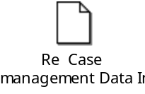

Contents
EY-EDP 2-HLD-v0.1 – Case Management Data Ingestion 1
Document Control 1
Introduction 4
Background 5
Business and Design Requirements 5
Scope 5
In Scope 5
Out of Scope 5
Design Factors 6
Design Risks 6
Design Dependencies 6
Design Assumptions 6
Design Decisions 6
Workload Design 7
2.1. Overview 7
2.1.1. Current Solution 7
2.1.2. Proposed Solution 8
2.1.3. High Level Solution Diagram 8
2.1.5. Interface Listing 9
2.1.6. Source Based Built-in Data Acquisition interfaces 9
2.1.7. EDP 2 Landing Zone 10
2.1.8. Integration Error Handling 10
Information Design 10
3.1. Information Domain decomposition 10
Subject Areas 10
Data Input and Output 17
Stored Datasets 18
3.4. Externalized Datasets 18
Technology and Infrastructure Design 19
4.1. Deployment 19
Technology Stack in Solution 20
4.3. Infrastructure Used 20
4.4. Data Storage and Growth 20
4.5. Resource Allocation 21
Security Design 22
5.1. Access Control 22
Role Based Access 22
5.3. Reports and Visualization 22
Power BI Users and Licenses 22
Testing Considerations 22
Pre-Production Environment 22
Design Dispensations 23
Appendices 23
Appendix A: Additional Document References 23
Ref 23
Document 23
Status 23
Version 23
Appendix B: Terminology 23

Introduction

Background
This document outlines the high-level design that EDP 2 platform team intends to leverage to develop code to integrate daily incremental data from Etihad’s Enterprise Data Platform (EDP) into EDP 2. This document is intended to attain provisional approval for promoting the Case management ingestion for two sources to EDP2 production. Customer data product detailed HLD would be updated in EDM confluence page. EDP2 approach and solution review is already done and captured in confluence page.
The scope for this phase of integration involves integrating the following two data sources from in Etihad’s Enterprise Data Platform 2 (EDP 2) to the Pulse CRM application:
1. OCR
2. Qualtrics
For OCR data Processing, we are getting four different files in encrypted format(.gpg) that are ingested by IBM team in SFTP Servers. We are using ADF pipelines that will copy the file from external sources (SFTP Servers) to Azure DataLake Gen 2. We are utilizing Databricks notebook to decrypt those files and will convert it into parquet format in raw folder which will further be loaded into external tables.
For Qualtrics data Ingestion, we will receive Json data from WEB API which later transformed to Parquet format using Azure services. These parquet files are loaded to Synapse as External tables as part of standard EDP2 Architecture.

Business and Design Requirements
With the introduction of new Enterprise Data Platform 2 (EDP 2), we will be processing the OCR and Qualtrics data on a daily basis.
We will be utilizing Azure Services to achieve this.
The scope for this integration work is to copy daily data available for OCR and Qualtrics and load it into External Tables.

Scope

In Scope
A process to push all relevant data related to OCR and Qualtrics to new EDP 2 platform

Out of Scope
This section, at a high level, lists the out-of-scope activities for the solution design.
Everything apart from mentioned HLD document

Design Factors

Design Risks
Ref | Design Risk | Impact  (L/M/H) | Likelihood  (L/M/H) | Mitigation
DRI001 | The solution is using Decryption key in order to decrypt the file. This could potentially be a risk if the key is expired. | H | H | Make the Validity of key to a high date eg: 2050-12-31

Design Dependencies
Ref | Design Dependency
DDP001 | Decryption key Availability
DDP002 | Availability of EDP2 Platform
DDP003 | ADF Pipelines to ingest data into EDP2
DDP004 | Design is based on existing EDP Platform

Design Assumptions
Ref | Design Assumption
DAS001 | ADLS Gen2 storage will be managed by EDP 2 team
DAS002 | Data will be ingested into ADLS Gen2 under EDP2 subscription
DAS003 | No duplicate check will be done for data

Design Decisions
Ref | Design Decision Statement | Options Considered | Chosen Option | Rationale
DDS001 | A process that will copy the file from SFTP server to ADLS Gen 2. | Option 1: Use ADF pipeline to copy the files. | Option 1 | Developer will have more control over the code  Easier to make changes/add more objects in future  Single code can be used to ingest different OCR files
DDS002 | A process that will be used to develop OCR Ingestion by decrypting the data. | Option 1: Use Python code in databricks decrypt the files. | Option 1 | Developer will have more control over the code  Easier to make changes/add more objects in future  Single code can be used to ingest different OCR files.
DDS003 | A process that will move the decrypted file to Raw folder in Parquet file. | Option 1: Use ADF to convert file into parquet and copy to Raw folder  Option 1: Use Python code in databricks to convert file into parquet and copy to Raw folder. | Option 2 | Developer will have more control over the code  Easier to make changes/add more objects in future  Single code can be used to ingest different OCR files.

Workload Design

2.1. Overview

2.1.1. Current Solution
Currently Solution is using EDP 1 Platform where we are getting the files on edge node and we are utilizing ZDP, HDFS and Hive table in order to load the the data.
The primary purpose of OCR D365 data feed export workflow is to transform and load OCR and Service Recovery Details which come in CSV format and stored in EDP and then uploaded to D365 as OCR Activity.
Qualtrics Workflow design starts from fetching data from Web API URL where data is received in the form of Json format which later transformed to CSV with Survey header and Response files. These data is then stored in Hive Tables.

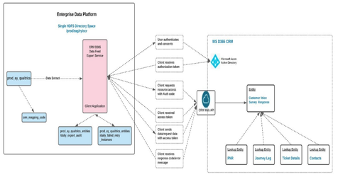
Figure: Current Overall export Feed process

2.1.2. Proposed Solution
Now , we are migrating jobs from EDP to EDP 2 where we are Utilizing Azure Service in order to load the data.
OCR workflow is to copy file from SFTP folder to ADLS Gen2 and load the OCR data to external tables. All the OCR related files present in SFTP server needs to copied to ALDS Gen2 and from there it would be decrypted and moved to Raw folder.
For Qualtrics, we are using ADF pipelines that will copy the file from external sources to Azure Data Lake Gen 2. We are utilizing Data bricks notebook to Parse those files and convert them to Parquet which later moved to external tables.

2.1.3. High Level Solution Diagram
The below figure depicts the information flow with the system for OCR.
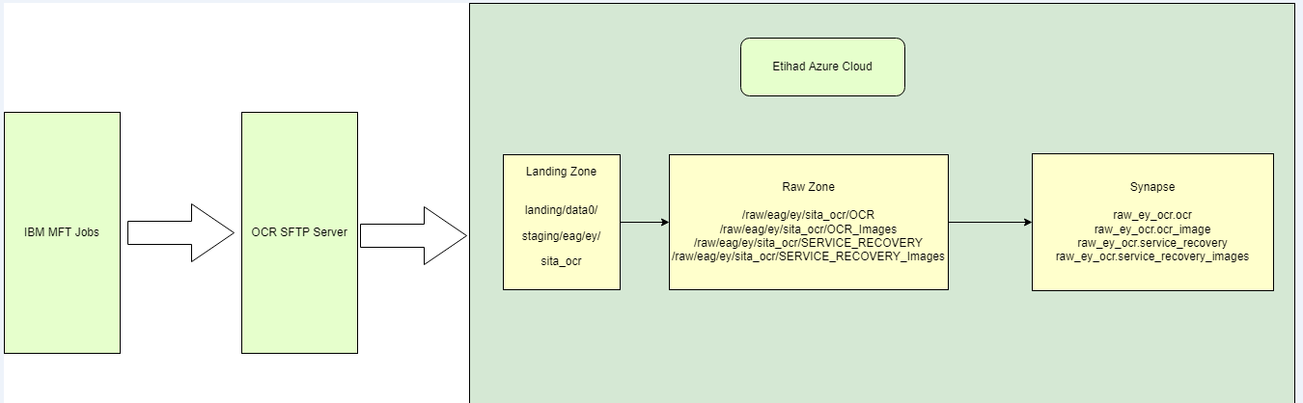
High Level Solution Design for Case Management of OCR

The participating components in the solution for OCR are:-

Solution Building Block | Type | Status
IBM Managed file transfer | To transfer the file to SFTP server | Existing
Source System for OCR | We receive 4 files in SFTP Server through IBM MFT jobs.
Landing zone | We will receive 4 files and are stored in Azure Data Lake storage Gen2.
Raw Zone | Post receiving the files, they are converted to parquet format.
Azure Synapse | We will use external tables from synapse to populate the data from raw zone.

The below figure depicts the information flow with the system for Qualtrics,
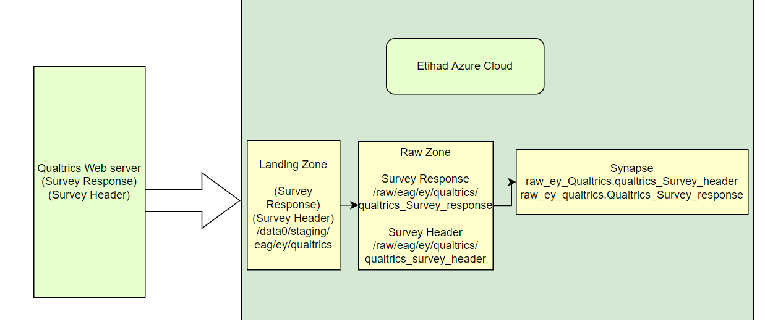

High Level Solution Design for Case Management of Qualtrics
The participating components in the solution are:-
Solution Building Block | Type | Status
Source System for Qualtrics | We receive header and response files from Qualtrics Web URL through API.
Landing zone | We will receive 2 files with name qualtrics_survey_header and Qualtrics_Survey_response and are stored in Azure Data Lake storage Gen2.
Raw Zone | Post receiving the files, they are converted to parquet format.
Azure Synapse | We will use external tables from synapse to populate the data from raw zone.

2.1.5. Interface Listing

2.1.6. Source Based Built-in Data Acquisition interfaces
This type of interfaces is built using:
- Source system built-in data extraction capabilities to extract relevant data sets from the source system of record database tables.
- Optional intermediary SFTP platform to stage the extracted file for file transfer interface to consume.
- Built-in file transfer capabilities OR IBM Managed file transfer platform to transfer the extracted data files to the landing zone of EDP edge node.
Sl No # | Interface Name | Source System | Target
1 | OCR E2E | SFTP Server | Synapse External Tables
2 | Qualtrics E2E | Web API | Synapse External Tables

2.1.7. EDP 2 Landing Zone
The zone details for data sources are provided below.
Source | Source Path
SFTP  Web API | landing/data0/staging/eag/ey/sita_ocr  landing/data0/staging/eag/ey/Qualtrics

2.1.8. Integration Error Handling
Below tables provide some main error scenarios that needs to be handled as part of Integration solution
Error Scenario | Description | Handling Action
No connection between SFTP source system and EDP 2 | Source system Server is not accessible to the EDP 2 interfaces. | The EDP 2 interface must capture followed by aborting the execution.
EDP 2 landing folder Not accessible | The target EDP 2 landing folder for delivery of data file is Not accessible. | The EDP 2 interface must capture followed by aborting the execution.  The source data file must be retained in the source location until next successful run.
Decryption Key Not Available/Working | The key to decrypt the data so that it can be processed further | The EDP 2 interface must capture the exception followed by aborting the execution.

Information Design

3.1. Information Domain decomposition
The information domains that will be modelled and physically implemented on the Enterprise Data Hub as part of FDW solution are depicted below:

Subject Areas
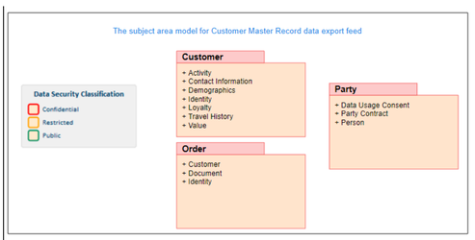
Subject Area Model

3.1.3. Business Information Map
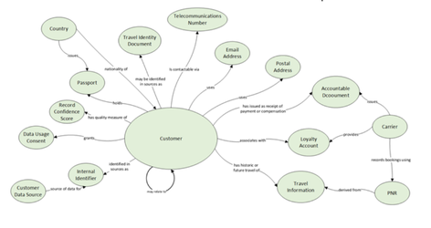
Following Attribute are related to OCR:
Table Name/View Name | Attribute/Column Name(View Level) | Data Type | Data Length | Primary Key (Yes/No) | PII Data | Definition | Data Classification | High Level Dataset Mapped
 |  |  |  |  | (Yes/ No) | Definition | (Public/ restricted/ confidential/ secret) | High Level Dataset Mapped
OCR | formId | bigint | 1-4,294,967,296 | Y | N | Unique number for the each line | Public | OCR
OCR | cc_staffid | string | 20 | Y | Yes | Cabin Crew Staff ID | confidential | OCR
OCR | cc_name | string | 100 | N | Yes | Cabin Crew Full Name | confidential | OCR
OCR | cc_email | string | 100 | N | Yes | Cabin Crew Email or Phone Number | confidential | OCR
OCR | cc_position | string | 50 | N | Yes | Cabin Crew Position | confidential | OCR
OCR | flt | string | 10 | Y | N | Flight Number | Public | OCR
OCR | flt_dep_date | string | 10 | Y | N | ? | Public | OCR
OCR | flt_dep_port | string | 5 | N | N | Flight Departure Station | public | OCR
OCR | flt_arr_port | string | 5 | N | N | Flight Arrival Station | public | OCR
OCR | ac_type | string | 50 | N | N | Aircraft Type | public | OCR
OCR | ac_registration | string | 50 | N | N | Aircraft Registration | public | OCR
OCR | paxcnt_first | int | 1-1000 | N | N | First Class Guest Count | restricted | OCR
OCR | paxcnt_busn | int | 1-1000 | N | N | Business Class Guest Count | restricted | OCR
OCR | paxcnt_econ | int | 1-1000 | N | N | Economy Class Guest Count | restricted | OCR
OCR | Crew_Report_to_AC_UTC | string | 23:59 | N | N | Crew Report to AC Time (UTC) | restricted | OCR
OCR | Boarding_Clearance_UTC | string | 23:59 | N | N | Boarding Clearance Time (UTC) | restricted | OCR
OCR | Door_Closed_UTC | string | 23:59 | N | N | Door Closed Time (UTC) | restricted | OCR
OCR | Delay_Code | string | 100 | N | N | Delay Code | restricted | OCR
OCR | events_List | string | 1000 | N | N | ";"(semicolon) separated list of Ticked Events | restricted | OCR
OCR | catering_events | string | 1000 | N | N | ";"(semicolon) separated list of Ticked Catering Events | restricted | OCR
OCR | serviceDelivery_events | string | 1000 | N | N | ";"(semicolon) separated list of Ticked Delivery Events | restricted | OCR
OCR | pax_name | string | 100 | N | Yes | Guest Full Name | confidential | OCR
OCR | pax_pnr | string | 20 | N | Yes | Guest PNR Number | confidential | OCR
OCR | pax_seat | string | 10 | N | Yes | Guest Seat Number | confidential | OCR
OCR | PAX_Contacts | string | 500 | N | Yes | Guest Contact Details | confidential | OCR
OCR | applicable_to_any_cabin | string | 100 | N | N | If this report is applicable to any cabin | restricted | OCR
OCR | Event_Title | string | 200 | N | N | Title of Event | restricted | OCR
OCR | Event_Description | string | 1000 | N | N | Detailed Description | confidential | OCR
OCR | Event_Action_Taken | string | 1000 | N | N | Immediate Action Taken | confidential | OCR
OCR | ingestion_date | string | 1000 | N | N | ingestion_date | Public | OCR
service_recovery | formId | bigint | 1-4,294,967,296 | Y | N | Unique number for the each line | restricted | Service Recovery
service_recovery | flt | string | 10 | Y | N | Flight Number | public | Service Recovery
service_recovery | flt_dep_date | string | 10 | Y | N | Flight Departure Date | public | Service Recovery
service_recovery | flt_dep_port | string | 5 | Y | N | Flight Departure Station | public | Service Recovery
service_recovery | flt_arr_port | string | 5 | N | N | Flight Arrival Station | public | Service Recovery
service_recovery | pax_name | string | 100 | N | Yes | Guest Full Name | confidential | Service Recovery
service_recovery | class | string | 50 | N | Yes | Class of Travel | confidential | Service Recovery
service_recovery | pax_seat | string | 10 | N | Yes | Guest Seat Number | confidential | Service Recovery
service_recovery | pax_country | string | 100 | N | Yes | Guest Country Name | confidential | Service Recovery
service_recovery | pax_address | string | 500 | N | Yes | Guest Contact Details | confidential | Service Recovery
service_recovery | ff_tier | string | 100 | N | N | Guest Flyer Tier | confidential | Service Recovery
service_recovery | ff_number | string | 50 | N | Yes | Guest Flyer Number | confidential | Service Recovery
service_recovery | pax_booking | string | 20 | N | Yes | Guest Booking Reference (PNR Number) | confidential | Service Recovery
service_recovery | pax_email | string | 100 | N | Yes | Guest Email Address | confidential | Service Recovery
service_recovery | pax_phone | string | 50 | N | Yes | Guest Phone Number | confidential | Service Recovery
service_recovery | incident_type | string | 100 | N | N | Incident Type | confidential | Service Recovery
service_recovery | compensation | string | 100 | N | N | Service Recovery Option | confidential | Service Recovery
service_recovery | voucher_serial | string | 100 | N | N | Voucher Serial Number | confidential | Service Recovery
service_recovery | followup_required | string | 5 | N | N | Follow Up Required? | restricted | Service Recovery
service_recovery | recovery_outcome | string | 1000 | N | N | Service Recovery Outcome | confidential | Service Recovery
service_recovery | cc_name | string | 100 | N | Yes | Cabin Crew Full Name | confidential | Service Recovery
service_recovery | cc_staffid | string | 20 | N | Yes | Cabin Crew Staff ID | confidential | Service Recovery
service_recovery | ingestion_date | string | 1000 | N | N | ingestion_date | Public | Service Recovery

Following Attributes for Qualtrics:
Table Name | Attribute/Column Name | Data Type | Data Length | Primary Key (Yes/No) | Definition | Data Classification | PII | High Level Dataset Mapped
QUALTRICS_SURVEY_HEADER | SURVEYID | STRING | 50 | Y | Survey ID | Confidential | No | Etihad Customer Survey
QUALTRICS_SURVEY_HEADER | SURVEYNAME | STRING | 250 |  | Survey Name | Confidential | No | Etihad Customer Survey
QUALTRICS_SURVEY_HEADER | STARTDATE | TIMESTAMP |  |  | Start Date | Confidential | No | Etihad Customer Survey
QUALTRICS_SURVEY_HEADER | ENDDATE | TIMESTAMP |  |  | End Date | Confidential | No | Etihad Customer Survey
QUALTRICS_SURVEY_HEADER | STATUS | INTEGER | 10 |  | Response Type | Confidential | No | Etihad Customer Survey
QUALTRICS_SURVEY_HEADER | IPADDRESS | STRING | 50 |  | IP Address | Confidential | Yes | Etihad Customer Survey
QUALTRICS_SURVEY_HEADER | PROGRESS | INTEGER | 10 |  | Progress | Confidential | No | Etihad Customer Survey
QUALTRICS_SURVEY_HEADER | DURATION | INTEGER | 10 |  | Duration (in seconds) | Confidential | No | Etihad Customer Survey
QUALTRICS_SURVEY_HEADER | FINISHED | INTEGER | 10 |  | Finished | Confidential | No | Etihad Customer Survey
QUALTRICS_SURVEY_HEADER | RECORDEDDATE | TIMESTAMP |  |  | Recorded Date | Confidential | No | Etihad Customer Survey
QUALTRICS_SURVEY_HEADER | RECORDID | STRING | 4000 |  | Record ID | Confidential | No | Etihad Customer Survey
QUALTRICS_SURVEY_HEADER | RESPONSEID | STRING | 50 | Y | Response ID | Confidential | No | Etihad Customer Survey
QUALTRICS_SURVEY_HEADER | RECIPIENTEMAIL | STRING | 100 |  | Recipient Email | Confidential | Yes | Etihad Customer Survey
QUALTRICS_SURVEY_HEADER | LOCATIONLATITUDE | DOUBLE |  |  | Location Latitude | Confidential | No | Etihad Customer Survey
QUALTRICS_SURVEY_HEADER | LOCATIONLONGITUDE | DOUBLE |  |  | Location Longitude | Confidential | No | Etihad Customer Survey
QUALTRICS_SURVEY_HEADER | DISTRIBUTIONCHANNEL | STRING | 20 |  | Distribution Channel | Confidential | No | Etihad Customer Survey
QUALTRICS_SURVEY_HEADER | USERLANGUAGE | STRING | 5 |  | User Language | Confidential | No | Etihad Customer Survey
QUALTRICS_SURVEY_HEADER | LOADDATETIME | TIMESTAMP |  |  | Load Timestamp | Confidential | No | Etihad Customer Survey
Transaction Data
QUALTRICS_SURVEY_RESPONSE | SURVEYID | STRING | 50 | Y | Survey ID | Confidential | No | Etihad Customer Survey
QUALTRICS_SURVEY_RESPONSE | SURVEYNAME | STRING | 250 |  | Survey Name | Confidential | No | Etihad Customer Survey
QUALTRICS_SURVEY_RESPONSE | RESPONSEID | STRING | 50 | Y | Response ID | Confidential | No | Etihad Customer Survey
QUALTRICS_SURVEY_RESPONSE | ATTRIBUTE | STRING | 4000 |  | Question ID or attribute name specific to the survey | Confidential | No | Etihad Customer Survey
QUALTRICS_SURVEY_RESPONSE | VALUE | STRING | 4000 |  | Attribute Value or Option Selected | Confidential | Yes | Etihad Customer Survey
QUALTRICS_SURVEY_RESPONSE | VALUE_LABEL | STRING | 250 |  | Label of the Selected Option | Confidential | No | Etihad Customer Survey
QUALTRICS_SURVEY_RESPONSE | LOADDATETIME | TIMESTAMP |  |  | Load Timestamp | Confidential | No | Etihad Customer Survey

Data Input and Output

Data Sources
It requires data from the below input data sets.
SL No. | Source | DD Path
1 | SFTP Server  Web API | /data0/staging/eag/ey/sita_ocr  /data0/staging/eag/ey/qualtrics

Filename | Description | Frequency | File size
OCR_<dateTimestamp>..csv.gpg | Encrypted CSV | Daily | Min 20 KB - 1 MB
Images_OCR_<dateTimestamp>.csv.gpg | Encrypted CSV | Daily | Min 20 KB – 50 MB
Service_Recovery_<dateTimestamp>.csv.gpg | Encrypted CSV | Daily | Min 1 KB - 1 MB
Images_Service_Recovery_<dateTimestamp>.csv.gpg | Encrypted CSV | Daily | Min 20 KB - 5 MB
Qualtrics_Survey | Zipped Json | Daily | 1-2 MiB

Stored Datasets

Raw Zone
Table Name | Path name | Security classification
ocr | /raw/eag/ey/sita_ocr/OCR | Confidential
ocr_images | /raw/eag/ey/sita_ocr/OCR_Images | Confidential
service_recovery | /raw/eag/ey/sita_ocr/SERVICE_RECOVERY | Confidential
service_recovery_images | /raw/eag/ey/sita_ocr/SERVICE_RECOVERY_Images | Confidential
Qualtrics_Survey_header | /raw/eag/ey/Qualtrics/Qualtrics_Survey_header | Confidential
Qualtrics_Survey_Response | /raw/eag/ey/Qualtrics/Qualtrics_Survey_response | Confidential

Refined Zone
Dataset Name | Table Name | Path name | Security classification | Contains PII?
n/a | n/a | n/a | n/a | n/a

Production Zone
Dataset Name | Table Name | Path name | Security classification | Contains PII?
n/a | n/a | n/a | n/a | n/a

3.4. Externalized Datasets
Datasets externalized for the purposes of loading the data are:-

Dataset: raw Schema
Table Name | Table Definition
raw_ey__ocr.ocr | OCR data is available in this table. This table is available in the raw_ey__ocr schema. EY - iKnow OCR (Onboard Crew Report) : Incident created on the EY iKnow application.
raw_ey__ocr.ocr_images | OCR Image data is available in this table. This table is available in the raw_ey__ocr schema.  EY - iKnow OCR (Onboard Crew Report) : Incident created on the EY iKnow application along with Image.
raw_ey__ocr.service_recovery | OCR Service Recovery data is available in this table. This table is available in the raw_ey__ocr schema.  EY - iKnow OCR (Onboard Crew Report) : EY iKnow OCR Guests details.
raw_ey__ocr.service_recovery_images | OCR Service Recovery Image data is available in this table. This table is available in the raw_ey__ocr schema.  EY - iKnow OCR (Onboard Crew Report) : EY iKnow OCR Guests details along with image.
raw_ey_qualtrics.qualtrics_survey_header | Header related data is available in this table
raw_ey_qualtrics.qualtrics_survey_response | Response related data is available in this table.

Technology and Infrastructure Design

4.1. Deployment
The below diagram shows the different technology components and the communication between them at platform level, that will be used for delivering the EDP 2 Workflow.
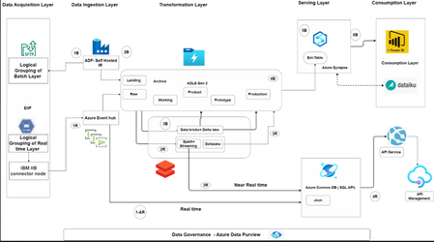
EDP 2 Workflow View

Technology Stack in Solution
The technologies and software tools used in this solution are listed below.
Name | Description | Status
Azure Data Factory | To create pipelines that will copy the data from SFTP server and also calling Databricks notebook. | Invest
Databricks Notebook | Using Python Notebook to decrypt the data and copy to different location in ADLS. | Invest
Azure Synapse | Creating External tables to load the processed data. | Invest

4.3. Infrastructure Used
Name | Type | Machine Spec | Installed Software

SFTP | SFTP Server |  | [EDP tools and technologies]
Additional infrastructure to be provisioned as part of this design is:-
Name | Type | Machine Spec | Installed Software
none | n/a | n/a | n/a

4.4. Data Storage and Growth
The required storage growth for Azure Synapse External tables
Store Name | Type | Historic Load (GB) | Incremental Load (GB/period) | First year growth (GB) | 3-year growth (GB)
ocr | ADLS Gen2 | .592 | .002/day | .73 | 2.19
ocr_images | ADLS Gen2 | 5.8 | .020/day | 7.3 | 21.9
service_recovery | ADLS Gen2 | 0.002242 | 0.0002242/day | .073 | .219
service_recovery_images | ADLS Gen2 | .0307 | .002/day | .73 | 2.19
Qualtrics_Survey_Response | ADLS Gen2 | 7 | 0.1/day | 3 | 9
Qualtrics_Survey_header | ADLS Gen2 | 1 | 0.01/day | 1 | 3

4.5. Resource Allocation
State which cluster configuration the solution will run in on PROD, and any known compute/memory/swap disk capacity usage requirements from prototype or SIT testing. Repeat for PPE if development is required there.
The estimated compute resources required for PROD are:-
Process | CPU cores | RAM (GB)
DataBricks Runtime Version 10.3 | 4 | 14 GB
The estimated compute resources required for Prod are:-
Process | CPU cores) | RAM (GB)
None | n/a | n/a

Security Design

5.1. Access Control
Once the identity of a user or system has been verified or authenticated, access control systems provide a level of granularity to control what the entity is able to access. This section describes how levels of access to resources are controlled from the integration solution perspective.

Role Based Access
The EDP 2 will be accessed by different group of users for their respective actions. Each of these groups will have to be provided with the right controlled access.
Dataset / Role | BizdataCRMusers | AzIngest_CRM | AzTrans_CRM | rawCRMusers
Landing Zone |  | RW | RW | RW
Raw Zone | R | RW | RW | R

5.3. Reports and Visualization

Power BI Users and Licenses
The below table outlines the expected user base for Power BI reports:
Use | BI Consumer  (Power Premium License) | BI Authors  (Power BI Pro License)
NA

Testing Considerations
All design solutions that will be deployed will follow the Etihad route-to-live process of Pre-Production and Production as appropriate to the type of development. This section defines the specific testing activities within each environment.
Note – The detailed test artefacts, test cases, test scripts are produced as separate document deliverables.

Pre-Production Environment
The Pre-prod environment will be used for the below activities during the implementation
- Development of migration scripts
- SIT ; UAT and Non-functional testing of OCR and qualitrics data ingestion

Design Dispensations
This section contains any design dispensations that are required due to not adhering to the Etihad Architecture Principles[X] or Etihad Policies.
Any design dispensation that that are required will need Etihad Architecture Review Board (ARB) approval and will be logged in the central Etihad Dispensations Log (see Information Architect for details).
Ref | Design Dispensation | Comment
TCR-<Innotas ID>-1 |  | n/a

Appendices

Appendix A: Additional Document References
Ref | Document | Status | Version
* Indicates document is not yet approved by Technology & Architecture

Appendix B: Terminology
Term | Definition
EDH | Etihad Enterprise Data Hub
EDP | Etihad Enterprise Data Platform
EIIP | Etihad Information and Integration Platform
MFT | Managed File Transfer
ETL | Extract, Transform and Load is a process in data warehousing responsible for pulling data out of the source systems and placing it into a data warehouse.
ICD | Interface Control document
RBAC | Role Based Access Control.
VPN | Virtual Private Network is a network connection that enables to create a secure connection over the public Internet to private networks at a remote location.
OCR | Onboard crew reporting

